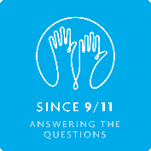**Theme 5: Terrorism**

### Key Questions

* What are terrorists?
* Where do they come from?
* What is the link between 9/11 and Islam? (And between other terrorist acts and other religions)
* Is terrorism a new phenomenon?

### Linking the theme to the subject topics

The issue of terrorism is covered through two topics:

* [History 2 – “Out of the blue”: When did 9/11 begin?](http://since911.com/node/55)

This topic looks at the role played by Al-Qaeda and the 9/11 terrorists in the 9/11 attacks.

* [Citizenship – How do we deal with terrorism?](http://since911.com/node/37)

This topic aims to develop students’ understanding of terrorism within a broader historical context and examines how governments deal with the threat posed by it.