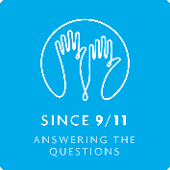**Theme 4: What was the impact of 9/11**

### Key Questions

* What was the impact in the UK, USA and globally?
* How has 9/11 affected me?
* How has it affected other people?

### Linking the theme to the subject topics

The consequences of 9/11 have been far-reaching – at global, national and personal levels. Two topics look at some of these consequences, especially in relation to how 9/11 has affected the lives of different communities and people – including those who lost relatives as a result of the attacks. The topics are:

* [History 3 – How has 9/11 shaped your world?](http://since911.com/node/56)
* [RE – What really matters in relation to 9/11?](http://since911.com/node/38)