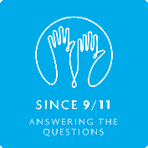**Theme 2: Why did it happen?**

### Key Questions

* What were the long and short term causes of 9/11?
* What are conspiracy theories and do they help us to understand why 9/11 happened?
* What was the role of Saddam Hussein/Afghanistan?

### Linking the theme to the subject topics

This theme is probably the most complex aspect of 9/11, and it is covered in systematic fashion through:

* [History 2 – “Out of the blue”: When did 9/11 begin?](http://since911.com/node/55)

This topic traces the causes of 9/11 back to the mid-19th century. It also includes a detailed consideration of the role played by Al-Qaeda and the 9/11 terrorists in the 9/11 attacks.